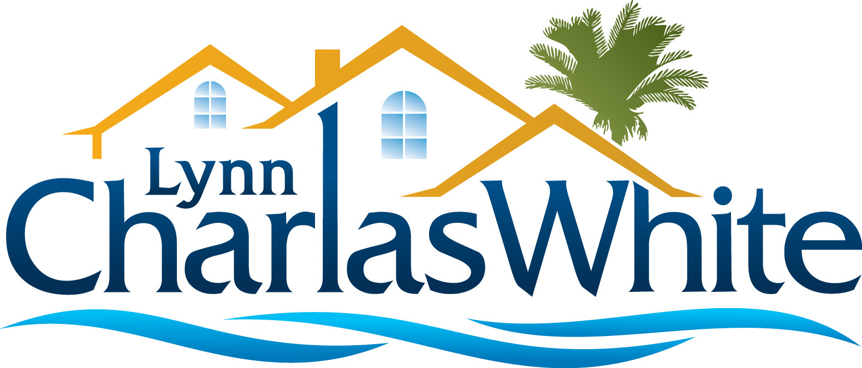

Natural gas is not as prevalent in Florida, so if this is important to you, you'll appreciate knowing which communities to focus on. Note that although this list is comprehensive, it may not be complete.

Naples
Aqua in Pelican Isle Mediterra
Audubon Moraya Bay
Aviano Quail West
Camden Lakes Quail Woods Estates
Collier's Reserve Talis Park
Fiddler's Creek Tarpon Bay
Grey Oaks The Dunes
Lokoya in Lely Resort Tiburon
Mercato Treviso Bay

Bonita Springs/Estero
Bonita Bay The Reserve at Estero
Bonita Lakes Verandah
Belle Lago Villa Palmeras
Carolands West Bay Club
Imperial Shores Wildcat Run
Palmira

